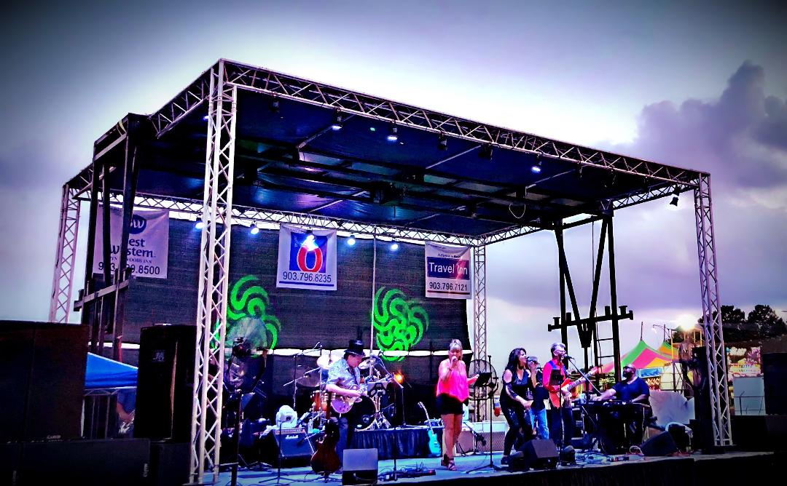  at your venue  Time Warpthe band  The Time Warp mission statement  Our mission is simple. Through dedication, hard work and perseverance, we bring a quality, family friendly live music experience to you. Your satisfaction is the key element in Time Warp’s approach to each show. We offer services from the small intimate gathering to medium and full festival event stage.  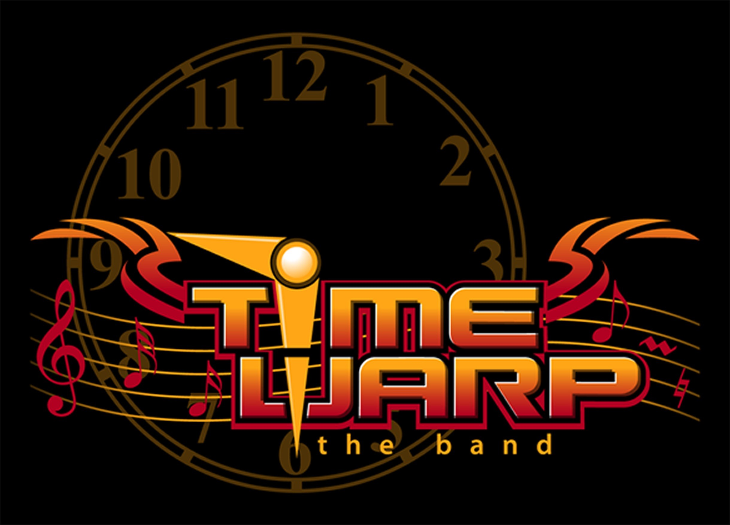 | We listen  To you!  ────  Covering many styles of music  60’s 70’s 80’s  On thru to current hits!  ────  We give you options  ────  We can accommodate  most budgets  ────  Professional appearance & musicianship  time warp  1217 Marydale  Arlington Tx 76013  817-797-6695  Timewarptheband.com  9am-9pm

